San Jose State University

EE250 (Section 2) Fall 2019 Prof. Kamali

Problem Set #7

- Problem 6.5
- Problem 6.7
- Problem 6.21
- Problem 6.41
- [Final Exam, Fall 2009] Suppose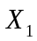,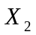, and 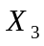 are three random variables defined as follows.

1. is a uniform random variable between [-3,3].
2. is a uniform random variable between [-2,2].
3. is a uniform random variable between [-1,1].
4. The correlation coefficients between these random variables are as follows.

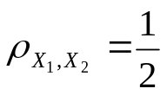, 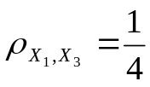, 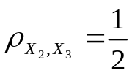

Find the covariance matrix 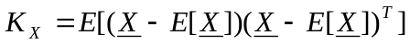 where 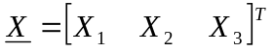.

- [Final examination, Fall 2015] The covariance matrix of the random vector 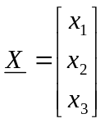is given as follows.

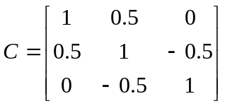

Find the correlation coefficient of 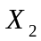and 

